Writeup assignment 2

CS383 Machine learning

Answers:

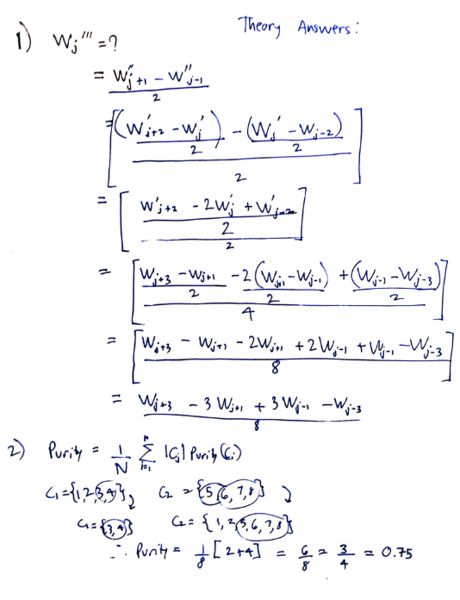

Notes:

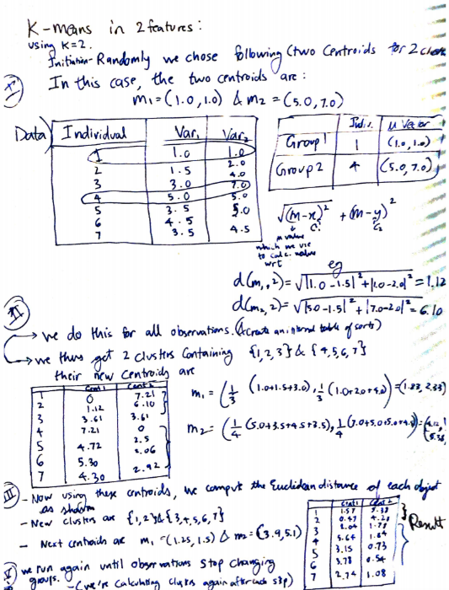

References:

<https://www.youtube.com/watch?v=DdlrYLqq71M>

<https://www.mathworks.com/help/matlab/math/basic-matrix-operations.html>

<https://www.mathworks.com/help/matlab/ref/double.normalize.html>

<https://www.mathworks.com/help/matlab/ref/colorspec.html>